# Output Screenshots:

This is the user interface of the Food Connect App

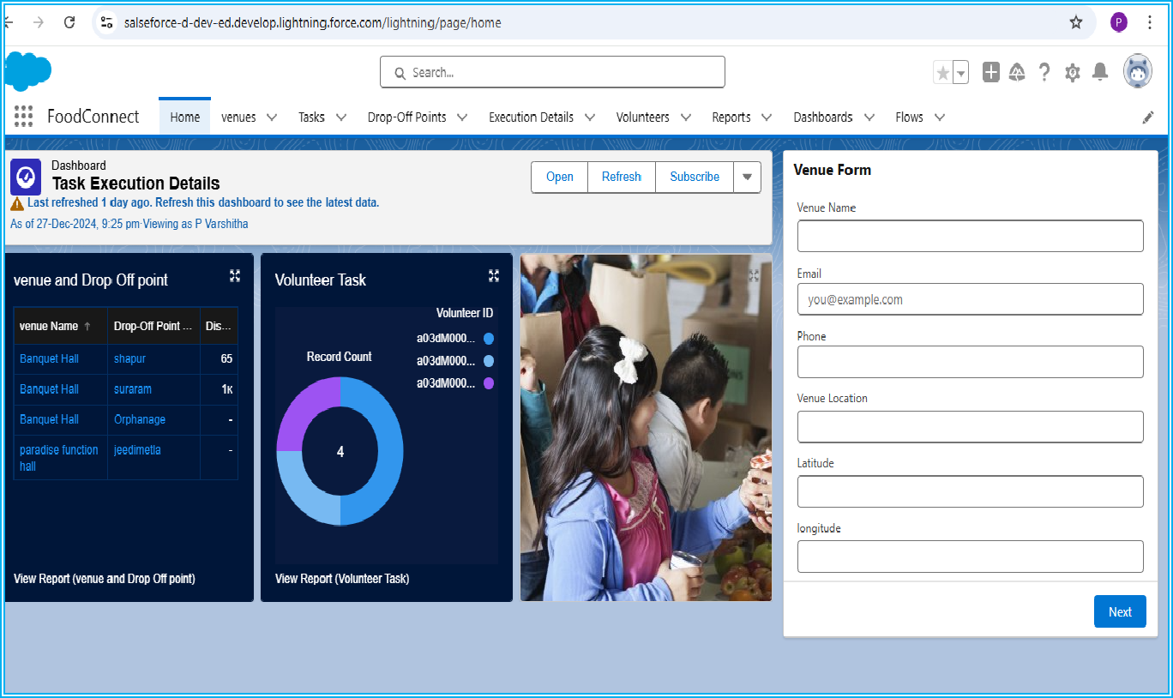

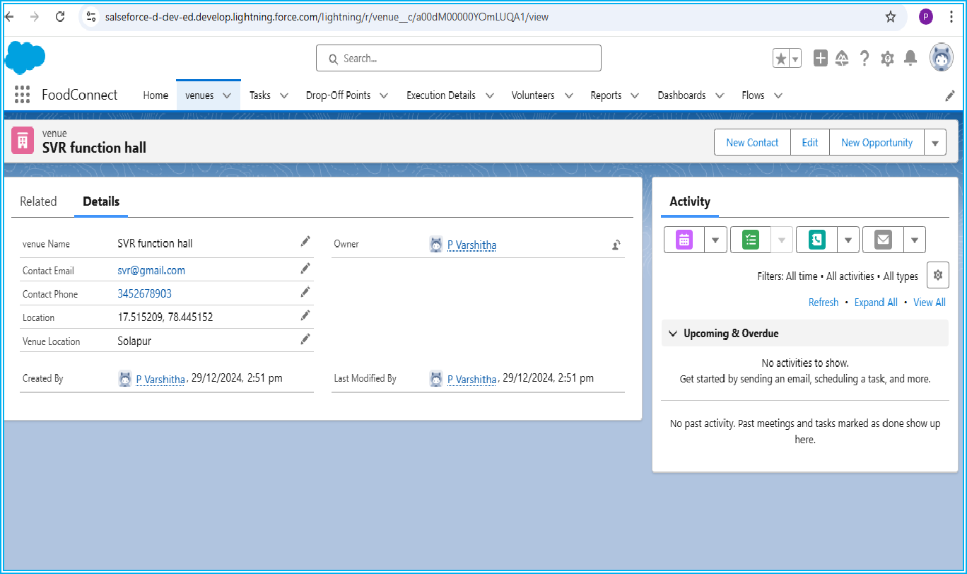If we click on the venue tab, it will look like this, then we have to enter the details.

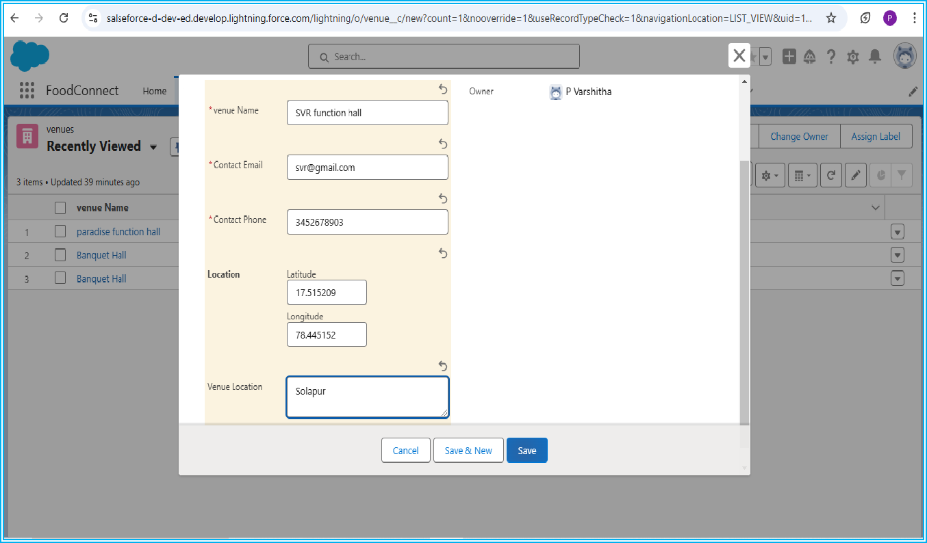

After that venue record will be saved.

If we click on the Drop-Off Point tab, it will look like this; then we have to enter the details and click on save.

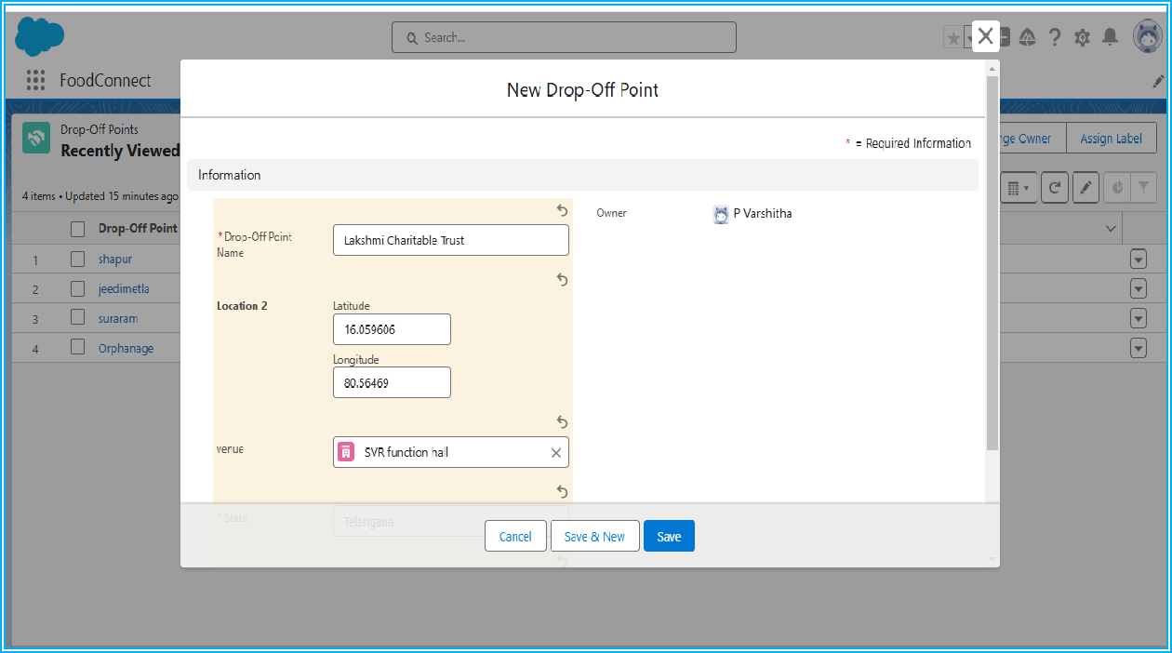

After that Drop-Off Point record will be saved and it appears as below.

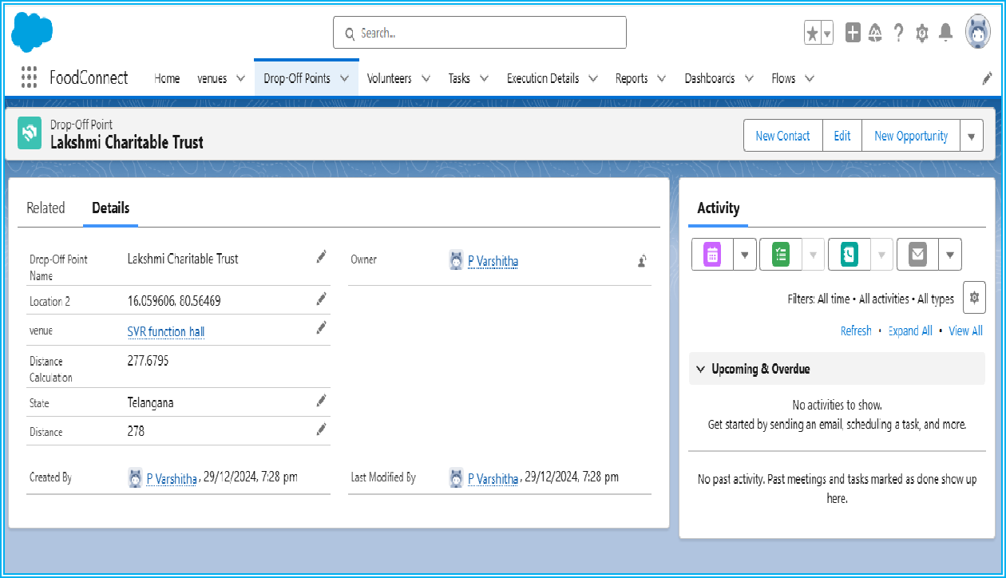

If we click on the volunteer tab, it will look like this; then we have to enter the details and click on save.

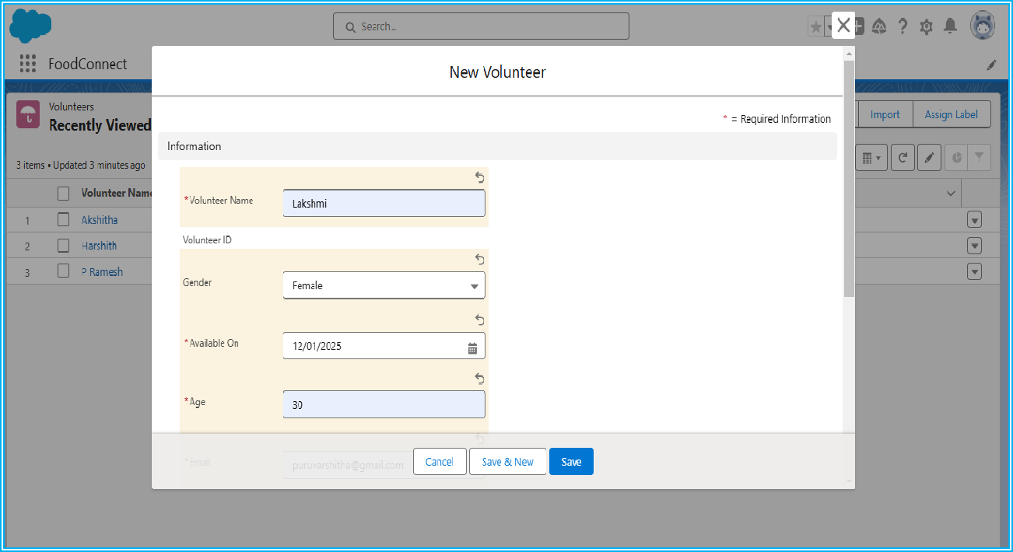

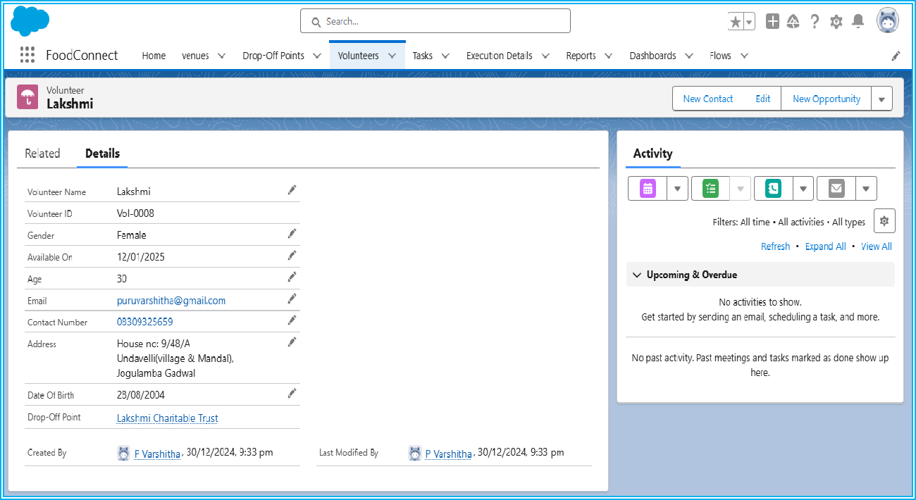After that volunteer record will be saved and it appears as below.

If we click on the task tab, it will look like this then we have to enter the details and click on save.

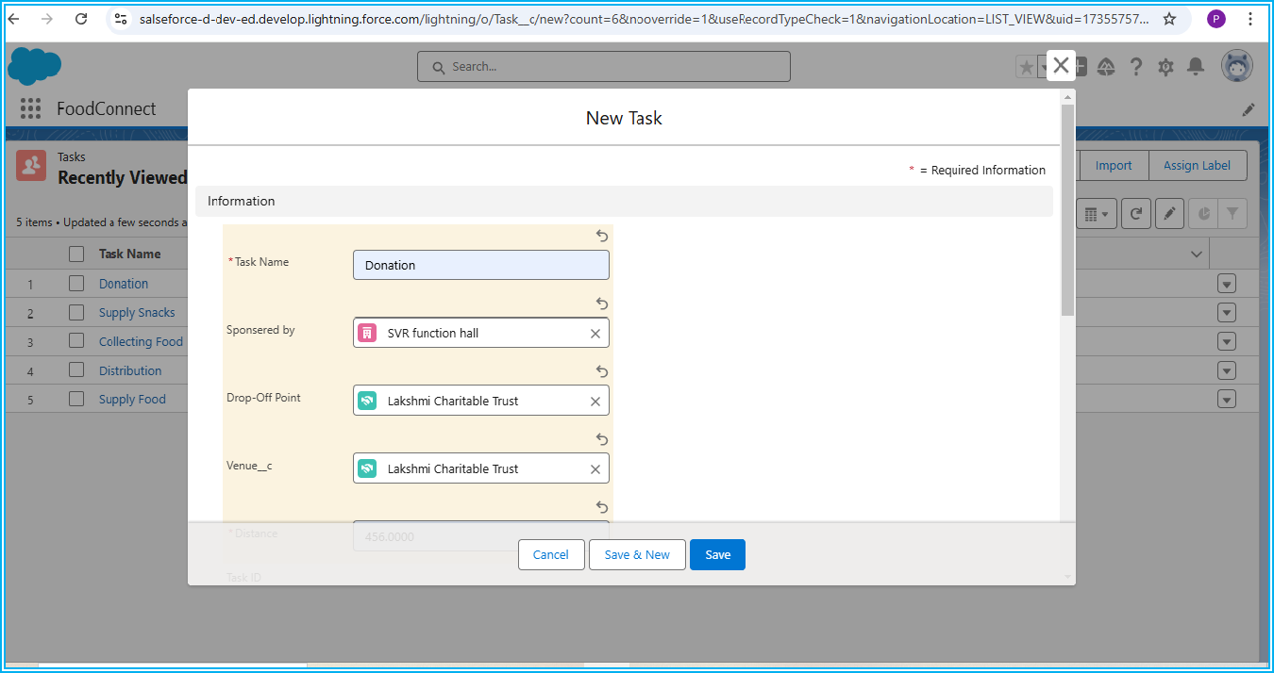

After that task record will be saved and it appears as below.

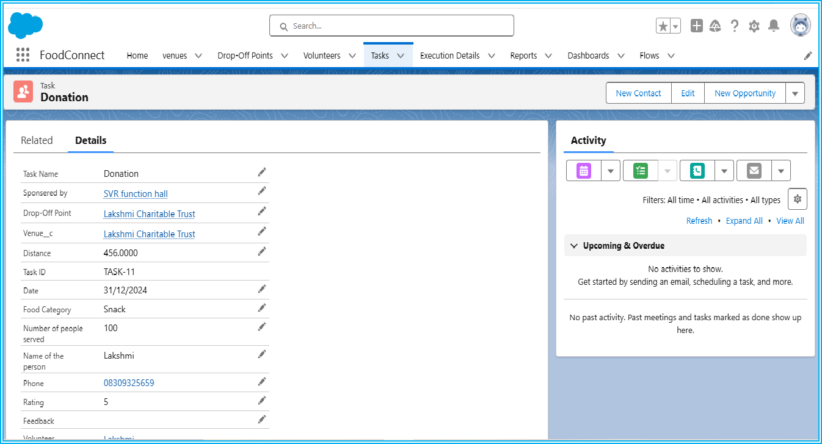

If we click on execution detail tab, it will look like this; then we have to enter the details and click on save.

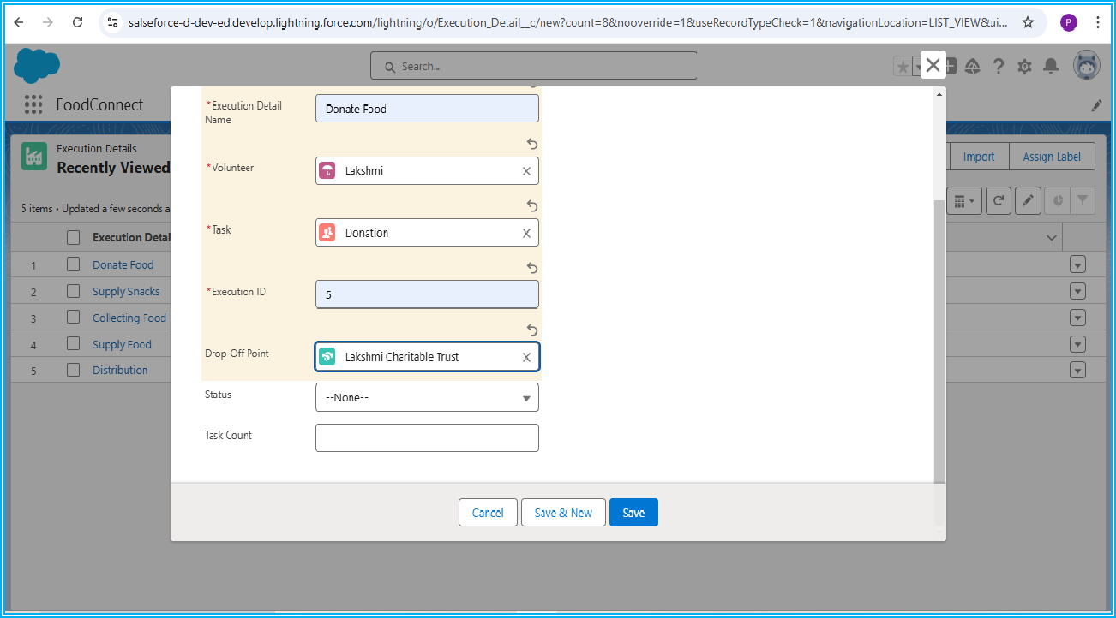

After that, the execution detail record will be saved and it appears as below.

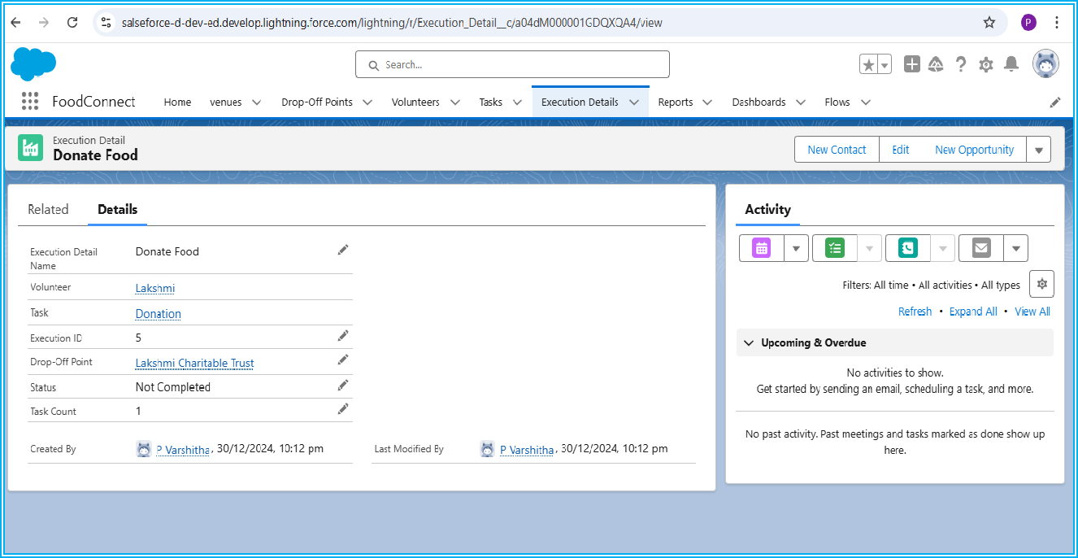

If we click on the reports tab, it will look like this, then we have to select the report which we want to see.

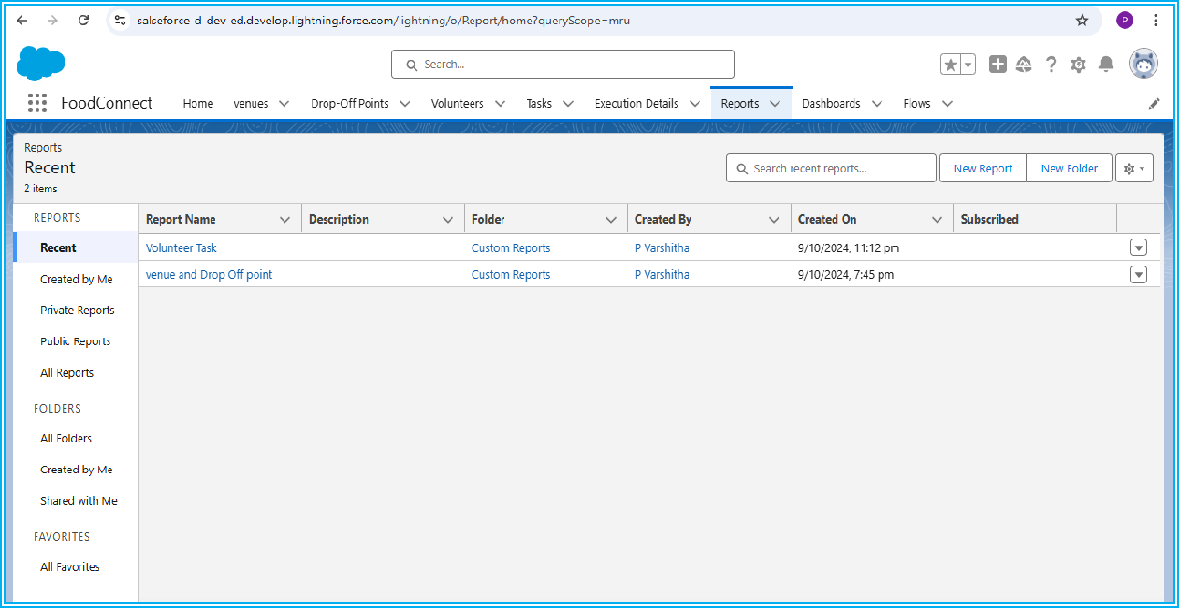

After selecting the report, it will show the report as below. It is the Volunteer Task report.

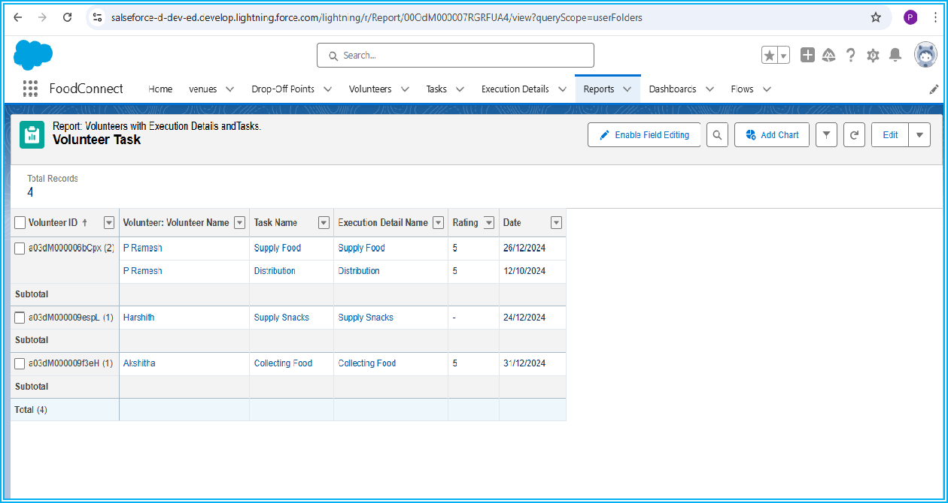

It is the Venue and drop-Off Point Report.

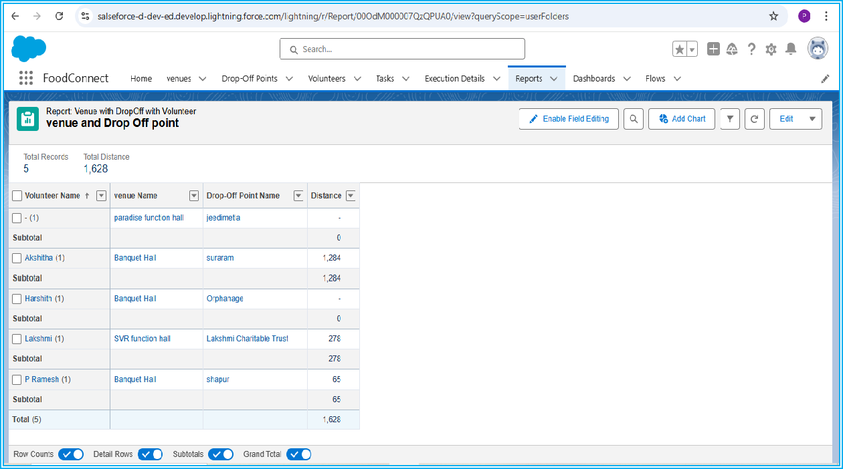

If we click on the dashboard tab, it will look like this, then we have to select the dashboard which we want to see.

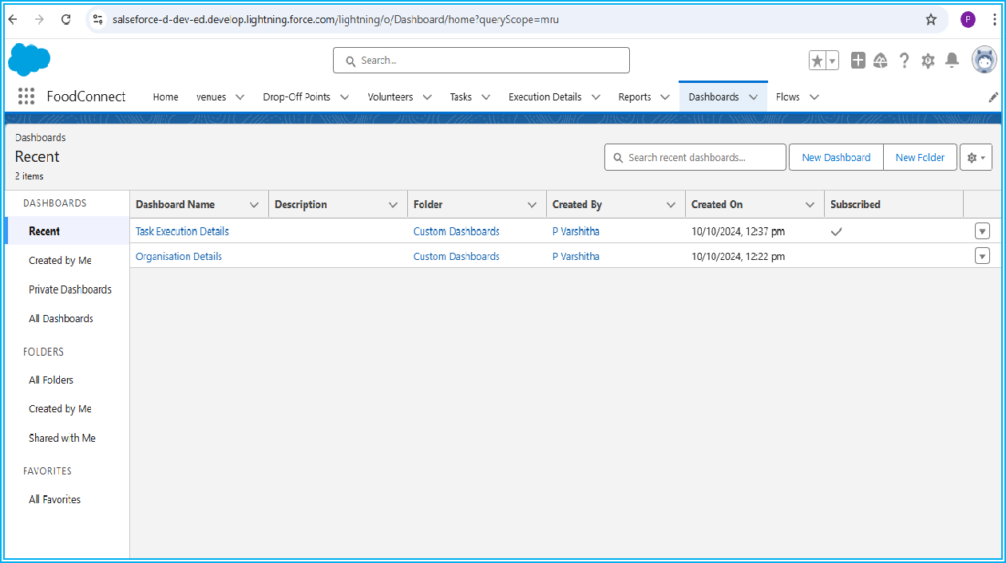

After selecting the dashboard, it will show the dashboard as below. It is the Task Execution Details Dashboard.

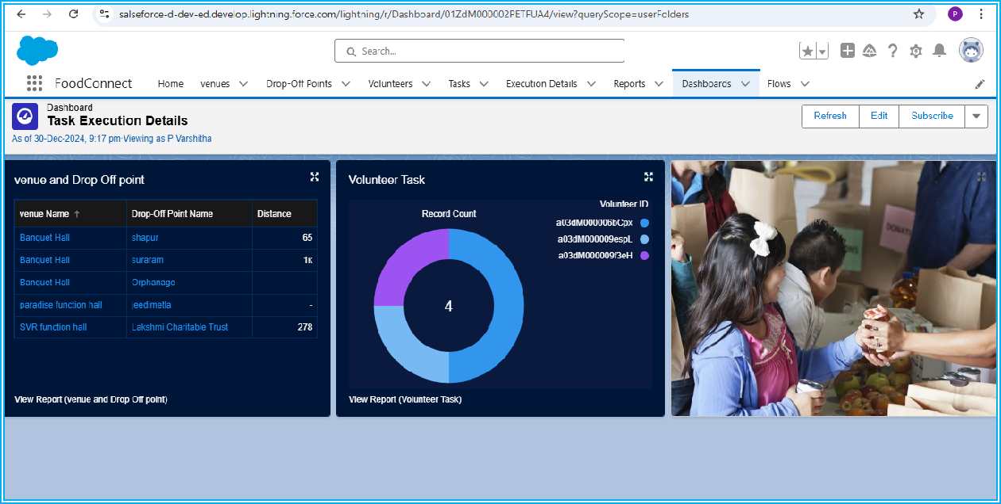

It is the Organization Details Dashboard.

